**Innovation,Employability and Entrepreneurship**

**SMART HOME**

SUBMITTED BY

A SRI VENI

961819106050

ECE

Ponjesly College of Engineering

Batch Number: B12-6A2E

**Door Buzzer Using Ultrasonic Sensor with Button**

**CODE:**

void setup()

{

Serial.begin(9600);

pinMode(4,INPUT);

pinMode(12,OUTPUT);

pinMode(2,INPUT);

}

void loop()

{

int p=digitalRead(4);

Serial.println(p);

if(p!=0)

{

for(int i=0;i<500;i=i+10)

{

tone(12,i);

delay(100);

noTone(12);

delay(100);

int a=digitalRead(2);

if(a==0)

break;

}

}

}

**TINKERCAD LINK:**

**<https://www.tinkercad.com/things/9IhvYYWfCgw-tremendous-crift-tumelo/editel?sharecode=iBoT2eO2jAUmLEyil6NPmvdC4FOf-KN0auAIQSN8Hic>**

**FIGURE:**

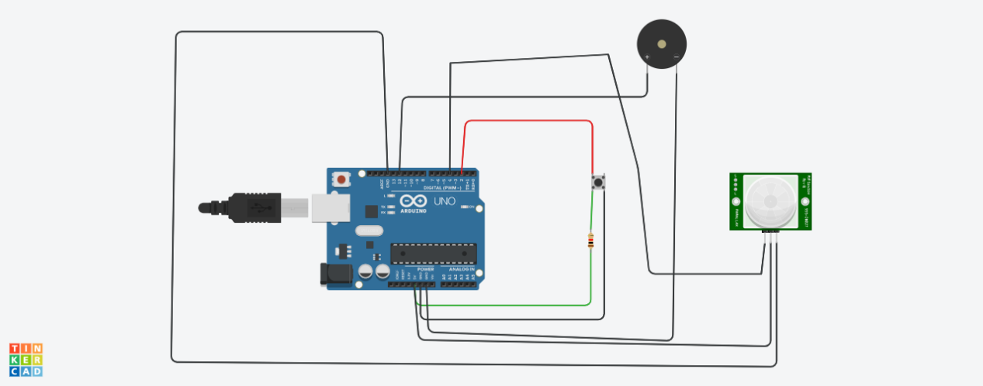

**DESCRIPTION:**

Whenever anyone comes in the path/range of Ultrasonic Sensor,Microcontroller detects the distance of object from the sensor and if the object is in the defined range,it sends the High Signal to the buzzer and the buzzer starts beeping.Then the sound of buzzer can be stop by using the button(it shows that the door has open).